|  |
| --- |
|  |

|  |
| --- |
| **Software Installation Plan** |
| [Type the document subtitle] |
|  |
| [Type the abstract of the document here. The abstract is typically a short summary of the contents of the document. Type the abstract of the document here. The abstract is typically a short summary of the contents of the document.] |
|  |
| **Jordan** |
| **[Pick the date]** |
|  |

Table of Contents

Introduction 2

Installation Method 2

Checklist - System Requirements 2

Checklist – Security Requirements 3

Checklist – Pre-installation Tasks and Resource Requirements 3

Installation Procedure 3

Post-Installation 3

Uninstallation Procedure 3

Sign-Off 3

# Introduction

* A brief background and history of the deployment project, which should include:
  + Brief description of the purpose of the program
  + Definitive version information for the program
  + Any other relevant supporting information

## Project description

The FTDC (Filename Time and Date Converter) will display…

* A drag drop box feature where multiple files can be dropped and dragged to.
* A textbox which can contain the directory path where the filename can be written to.
* A button which will create a copy of the files in the drag drop box with the time and date they were created. A copy of the files will be inserted into the file path entered into the end of the directory path which is in our textbox.

## Version

Author: Jordan Nash

FTDC_Beta_V11

C# .NET 4.5

# Installation Method

We will use the open source [InnoSetup](http://www.jrsoftware.org/isinfo.php) third party installion tool as it has a neat packaging feature in which you only need one executable file.which will contain all needed DLLs (Dynamic Link Libraries), .pdb (Program Debug Database files) and theXML Configuration File (.config) to operate the application.

# Checklist - System Requirements

* **Required runtimes:** [.NET 4.5 framework.](https://www.microsoft.com/en-in/download/details.aspx?id=30653)
* **Disk space:** 747kb.
* **Supported Operating System**

Windows 7 Service Pack 1, Windows Server 2008 R2 SP1, Windows Server 2008 Service Pack 2, Windows Vista Service Pack 2

* Windows Vista SP2 (x86 and x64)
* Windows 7 SP1 (x86 and x64)
* Windows Server 2008 R2 SP1 (x64)
* Windows Server 2008 SP2 (x86 and x64)
* **Hardware Requirements:**
* 1 GHz or faster processor
* 512 MB of RAM
* 850 MB of available hard disk space (x86)
* 2 GB hard drive (x64)

# Checklist – Security Requirements

None.

# Checklist – Pre-installation Tasks and Resource Requirements

Step 1 Select release:

From the dropdown box where Debug will be listed, please select Release if it is not already selected.

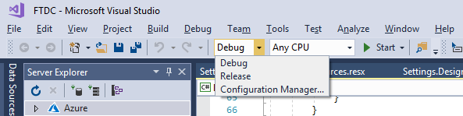

Step 2 Check if the binary components have generated:

Click Build and from the drop down menu select “Build Solution”.

A Release sub folder should now have been created in your bin directory. 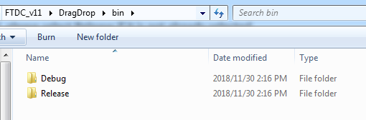

Inside that folder should be the files…

* FTDC.exe (you may not see exe listed. Right click and go to properties to make sure it’s an exe file.)
* FTDC.exe.config
* FTDC.pdb

These files shall be included in the final installation.

# Installation Procedure

* This section must be as clear and explicit as possible listing all the steps (and include screenshots), in chronological order the installer must follow to complete the deployment process.
* This section must also include the detailed steps in the deployment of the database.

## Step 1 Open Inno Setup Script Wizard

Open the Inno Setup application and go to File > New and you should then get this prompt. Go ahead and generate an empty script file if you want to change the installations settings later and hit next. It will tell you that you have finished creating a empty script if you left the box ticked. Repeat the process and go to File > New and go to next on the prompt.

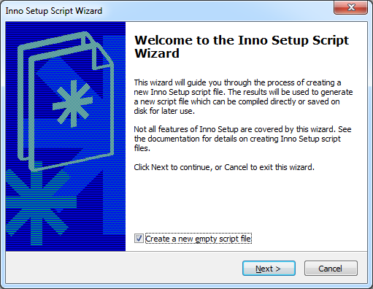

## Step 2 Enter information about the application

Enter your information. I have entered my own information. Note with the version you want something consistent. If you open up the Programs and Features in Control Panel in Windows then you will see the version number for each application installed onto your computer. Hit next.

## 

## Step 3 Name the folder installation folder and specify base application folder

You should leave the **Application destination base folder** selection as it is unless client wants application to specifically install somewhere else and leave **Application folder name:** as it is.

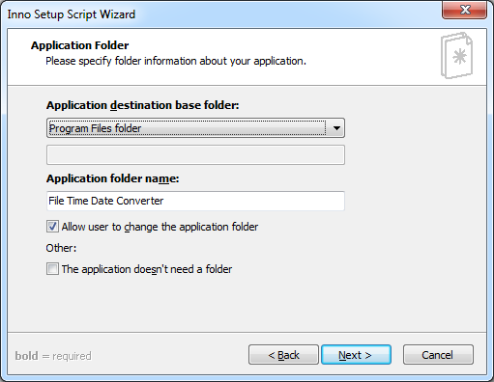

## Step 4 Setup executable and support application files

This is where you need to add the files in the Release folder manually that we talked about on page 4. Firstly untick where it says “The application doesn’t have a main executable file.” Then hit “**Browse**” for the file FTDC.exe and set that as your executable starting point file for the user. Then add files by clicking the “**Add file(s)**” button and add the files “FTDC.exe.config” and “FTDC.pdb”.

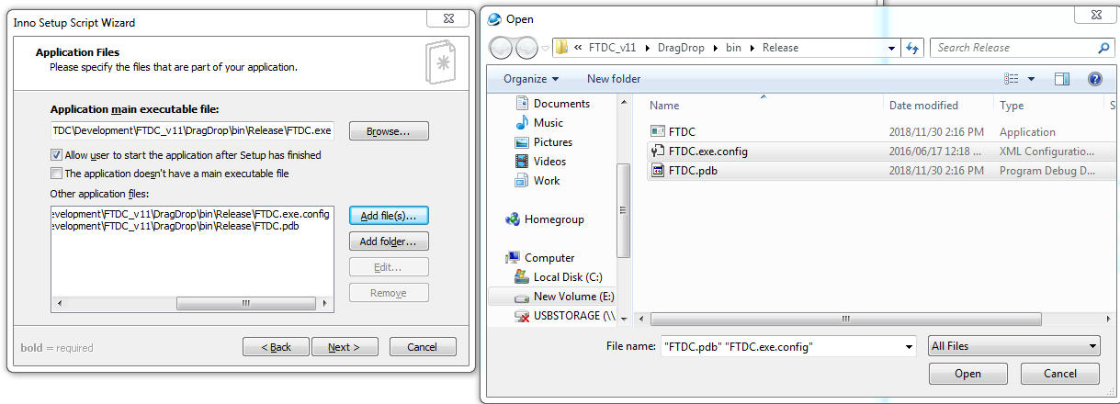

## Step 5 Create shortcuts for user

You can just leave this as it is and hit “Next.”

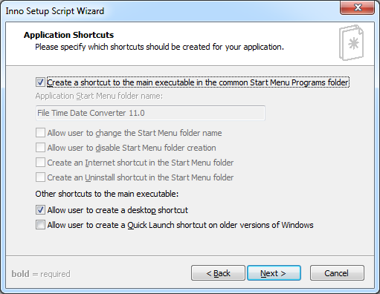

## Step 6 Add documentation files… or not?

To add or not to add, such as is the question. It’s up to you. I have my own license file that I downloaded from here. <https://choosealicense.com/licenses/gpl-3.0/>

I also added a README text file containing basic information about the application. It’s up to you on what you want to do here. You could just ignore it completely and hit “next”.

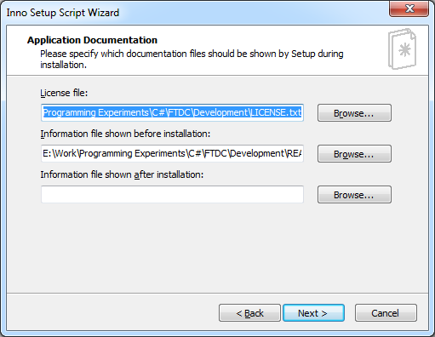

## Step 7 Configure complier output

In the 1st text field you must enter where the setup file will be written to. In the 2nd text field you should also specify the name of your setup package. In a real world setting you would decide on the icon of the application with the client but we are not making this for a client so we will leave our icon field blank.

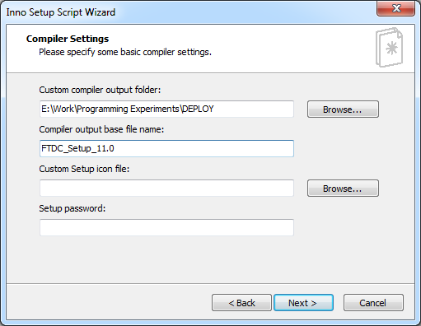

## Step 7 Use Inno Setup Preprocessor

Highly recommended you leave that section ticked so you can customize the script later if needed without having to go through the whole wizard again. Just hit “Next” and go to “Finish”. You should find the application in the folder you specified in step 7.

# 

# Post-Installation

|  |  |  |
| --- | --- | --- |
| Description | Yes? | No? |
| Test the program to see if files are copied with Time and date of creation to folder. |  |  |
| Check .NET is set to auto update. |  |  |
| Check firewall, briefly. |  |  |
| Make a short cut on client computer desktop, or do it the client’s way. |  |  |

# Uninstallation Procedure

Too easy. If you’ve installed the app then go to its folder and click **unins000.** Don’t rename the uninstall file or it won’t work. That is another application I did in College.

